Class – Help Document


How to produce a report to show what agents are sending the most number of students

Create an ‘Enrolment-General’ Quick Report

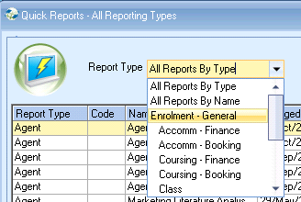

Enter your required date filter and date range.
Add the fields as shown below.

Sorting -
1st sort = Agent Name
2nd sort = Enrolment Duration Weeks Rounded (untick Ascending)

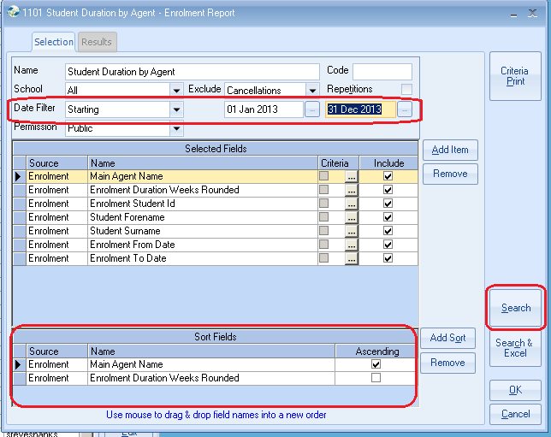

Select SEARCH
This will display the Results page.

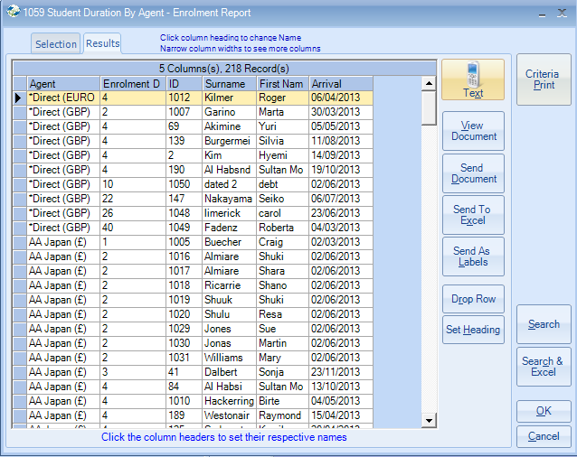

Select SEND TO EXCEL

- Go to the ‘SUB TOTALS’ tab.
- Set as below.
- Tick Duration - this might be displayed as ‘Enrolment Duration Weeks’

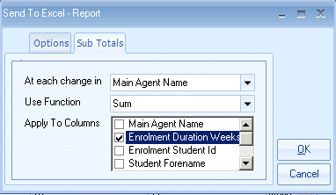

Select OK

This will send the results to an Excel spreadsheet sorted by agent name and then by the duration of each student booked with that agent with the longest students duration first.

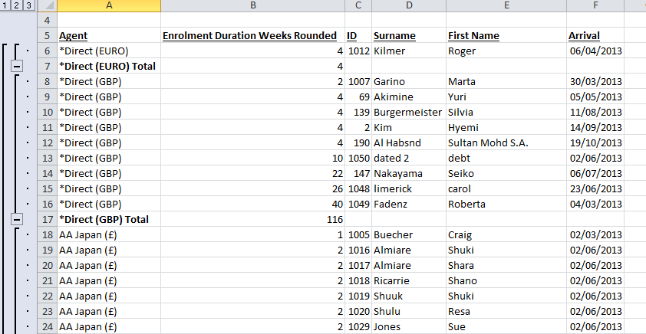

Click on the “2” in the left column.

This will show each agent with the total duration of all students booked with the agent, based on the date range selected.

