Class – Help Document


UKBA SMS Bulk Export

Relevant details from Visa dependant enrolments can be exported, creating a file for uploading to the UKBA website. Infospeed has maximised what can be achieved in relation to the limited functionality provided by UKBA.

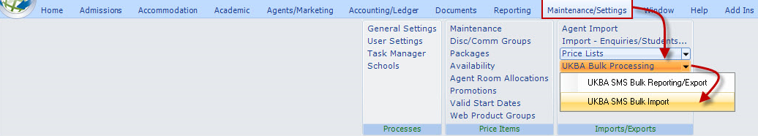

Prior to using this facility, ensure the following has been set up:

School Record:
- Maintenance/Settings
- Schools
Check school UKBA details are correct.

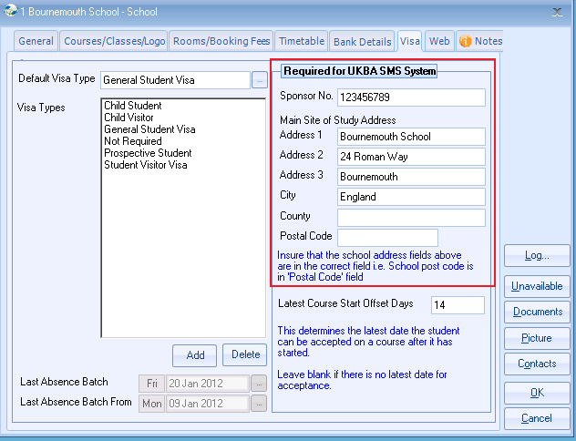
Country/Nationality ISO Codes are valid

- Maintenance/Settings
- General Settings
- Company
- International/Nationalities – also check Settings/International/Countries

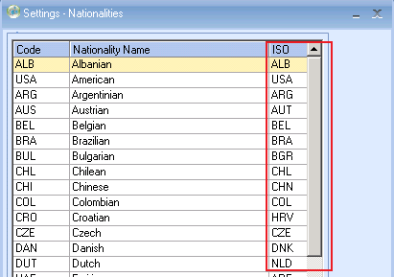

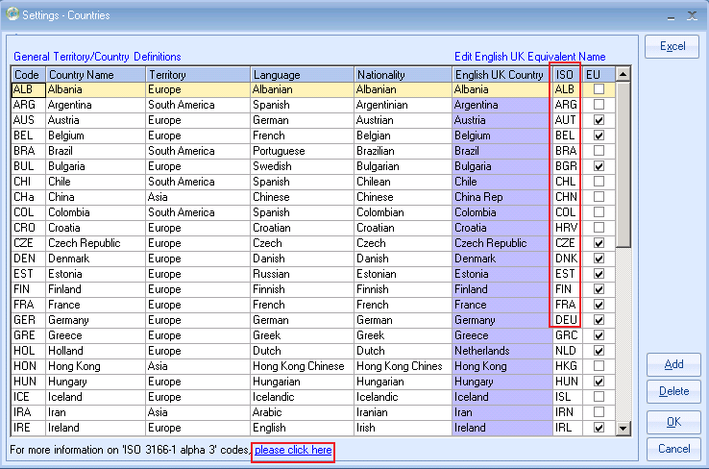

Use the link at the bottom of the screen to get a full list of available codes and manually update accordingly. Wrongly entered codes will be checked when the export is prepared and any invalid codes will need correcting.

Report/Export Browse

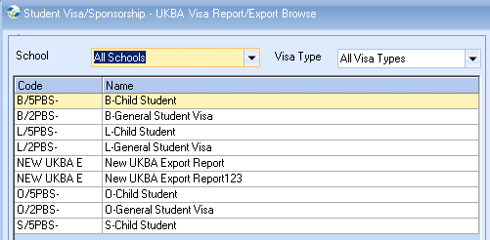

Note: Child and Adult files for each school are required.

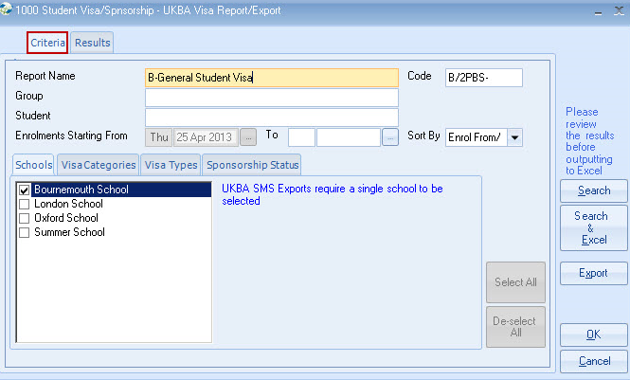

- Please remember to enter filters at bottom of selection screen.
- Returned results can be exported to Excel, prior to export.

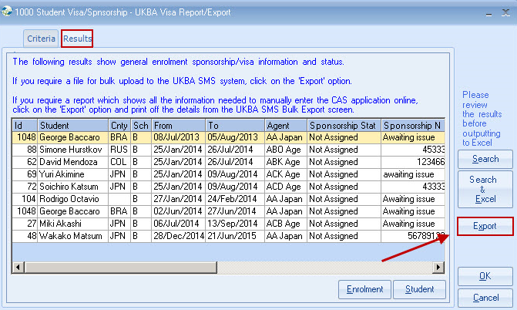

For Manual or file update to the UKBA SMS system select “Export.”
Note: The Excel button (prior to export) provides limited detail. (Export first then use Excel if manual update is required)

The sample screen below shows export records (in RED) failing UKBA validation, and must be corrected before the export file can be created. Even if the update to the UKBA website is to be done manually records should be corrected to ensure their integrity prior to producing the Excel report.

Validation failures are shown in a notepad (double click Failures cell). The notepad can be moved/minimised whilst correcting records (double click row to correct record).
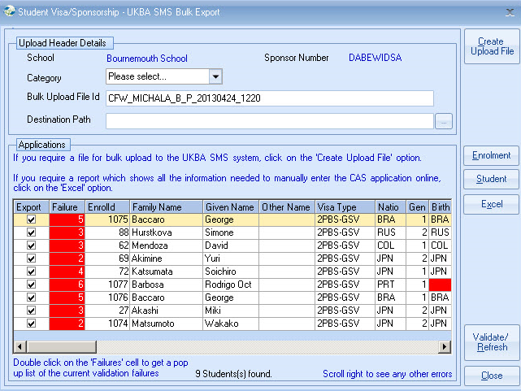

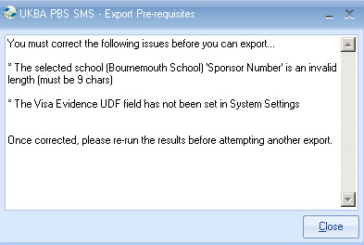

After correcting validation failures users wishing to create a file for upload to the UKBA SMS website should follow the following instructions. Please note UKBA have not provided a means of directly sending the file to them, and the process below is the only method provided.

Create/Upload Instructions

Before clicking ‘Create Upload File’ insure that the ‘Category’ of either ‘Child’ or ‘General’ has been selected from the dropdown list and that the ‘Destination Path’ has been specified.

Once the file has been successfully created at the ‘Destination Path’ location, the enrolments linked to the export records will have their Sponsorship Status field automatically updated to ‘Requested’.

After the creation of the file a message will indicate successful creation and also give the option to open up the UKBA SMS website login screen.

Browse to the XML file using ‘Windows Explorer’ or ‘My Computer’

The export file needs to be sent to the UKBA website in a compressed .zip format. This can be done using a compression tool such as WinZip or alternatively you can use the built in compression utility with Windows XP.
Right click on the xml file in Windows Explorer and select ‘Send To’ from the Popup menu and then select ‘Compressed (zipped) Folder’.

The subsequently generated .zip file can now be imported into and then viewed from within the SMS website using the functionality provided online.

UKBA SMS Bulk Import

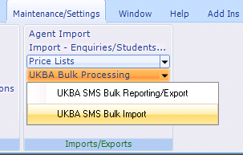

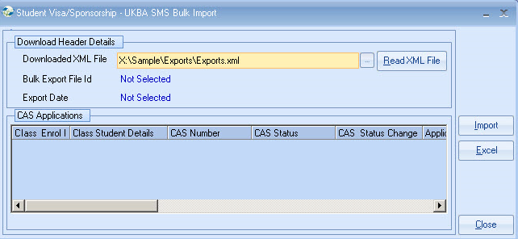

Import Instructions

The UKBA SMS Bulk Import allows batches of CAS Applications to be imported back into Class.

Once validated and imported the matching Class enrolment details are updated with the relevant CAS Number and Status as well as an official Dated Note being created, stamping the date, time and File Id the information was updated from.

Bulk export files from the UKBA website are downloaded as .zip compressed files that need to have their xml files extracted using the extraction program from with Windows XP or WinZip for example.

Once the XML file has been extracted, click the file browse button to locate the required XML file to be imported.

Click ‘Read XML File’ to open and validate the xml file.

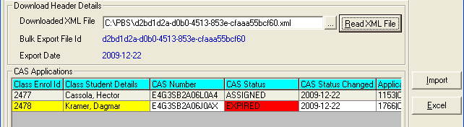

The first checks done on the file are to insure that all the CAS Applications originated from a Class UKBA Export and that they are from the Class database (Company) that the user is currently logged into. If any applications fail this test the whole batch is rejected as the system is unable to guarantee a correct match when linking back to the enrolments in Class.

On successful validation of the database the applications in the batch will be shown in the grid.

A CAS Status highlighted in red is an indicator that the status is not ‘Assigned’.

If the fields ‘Class Enrol Id’ and ‘Class Student Details’ contain values but are yellow it indicates that a match has been found on the enrolment in Class but one or more of the student details do not match the import file (this could be due to a slight change in the spelling of the students name for example). This is still a potentially valid import but the user should double check that the matched student is the correct enrolment.

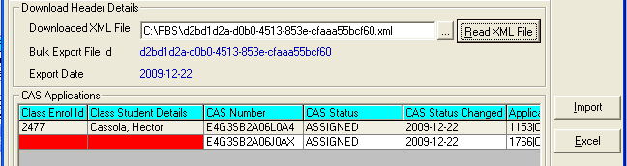

If the fields ‘Class Enrol Id’ and ‘Class Student Details’ are red and no enrolment Id is present then the system was unable to match the import file details to a record in Class. This will stop the import as all applications must be valid for a bulk import to Class.

Click ‘Import’ to extract the details from the import file and update the relevant fields within the matched enrolments.

