

Class – Help Document

How to book Accommodation within an Enrolment

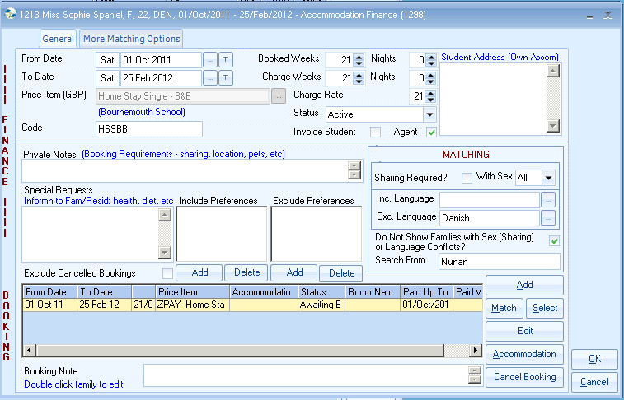

The top part of the screen is “Accommodation FINANCE” and is used in the calculation of the invoice value.

The bottom half is the “Accommodation BOOKING,” reflecting the Accommodation booking part of the process e.g. host family

If a student has own accommodation, enter details in the top right hand corner

FINANCE

From/To/Weeks
Class pre fills these fields with the arrival/departure dates. Amend if necessary.

Price Item
Select the Price Item.
Once, a Price Item has been selected only dates can be changed.
If the wrong Item has been chosen cancel the entry and start again.

Code
Price item code – Entered by Class

Booked Weeks = Actual duration
Charge Weeks = Charged duration
Charge Rate = Rate used for booking

Permission settings will need enabling to allow results which produce “lower” prices, based on the 3 variables above, to be changed.

Invoice Student/Agent
Defaults - “Agent” for agent bookings and “Student” for “Direct” agent bookings. Flag can be changed if required e.g. Agent requests that accommodation is invoiced directly to the student.

Private Notes
Internal notes, typically used to indicate a particular issue – e.g. wants to share with Y, wants to stay with Mrs X, wants to be near a bus route etc.
In addition to the above, smoking, pets, children information, etc. can be entered which can later be interpreted by the accommodation officer.
Alternatively, this information is entered into the Preference fields.

Special Requests
This entry is normally merged into the confirmation documents to the Host Family, e.g. dietary requirements

The Special request comment also appears in the Accommodation Bookings Report.

The various note boxes can be used in a variety of ways and above is only one suggestion

Preferences (Include/Exclude)
Add as required. Used by the “Match” process.

Booking Note for Family letter:
This is specific to the booking line i.e. to that family. The note shows on Accommodation Bookings report. To update double click on the booking line.

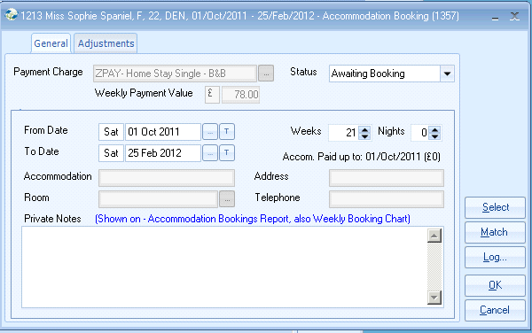

BOOKING

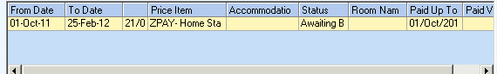

The booking line indicates that there is accommodation to be booked – “awaiting booking.” Details of this requirement will appear on the Accommodation Bookings Report to alert the accommodation officer.

Booking Accommodation
Accommodation is normally booked at a later stage, after registration is complete, and as a result of appearing on the Accommodation Bookings Report.

The accommodation officer may already know the family to book and will in this case press “Select” to allocate the family. If not, the system can be used to help find an available family by using the “Match” option. Available families are listed.

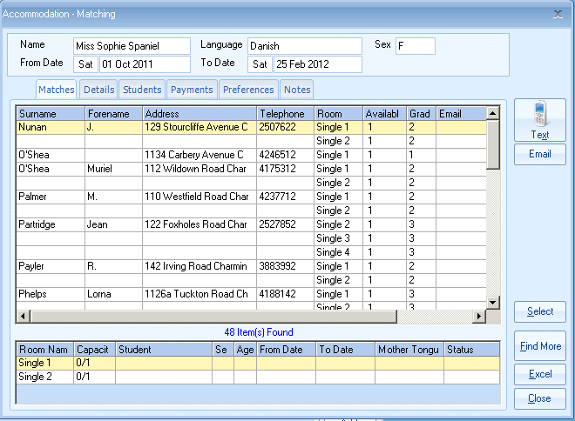
Available families
Full details of each family
Rooms available + details of other students

The criteria used by the system:
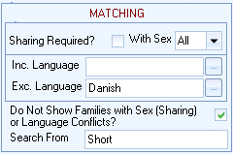

Include conflicts? The system will automatically exclude sex/language conflicts. If this field is un-ticked then conflicts will be shown (in Red). In this example the search will start at “Wilson.” (This can be set to any start point if required)

Additional selection criteria is available by selecting “More Matching Options”
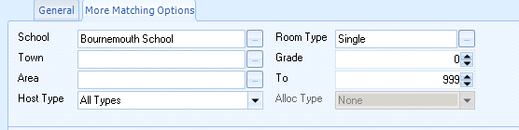

Booking the family
Highlight and double click the required family.

Cancelling a booking (before student arrives)
An entry may be cancelled by highlighting the item in the Bookings screen and selecting, “Cancel Item.”
The Status will change automatically.

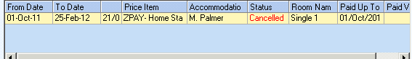

Cancelled bookings are automatically printed on the Accommodation Bookings Report. To acknowledge to the system that the cancellation has been actioned select the booking line and change the status to Acioned.

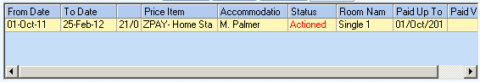

Changes to Accommodation
Reducing time with Home stay – e.g. booked 8 weeks accommodation, now only requires 4 weeks.

Change the FINANCE “To Date”. System will prompt to re-finance – if a refund is due answer Yes, if no refund is due answer No.
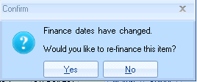
If a refund is not due – answer No

The system on selecting OK will offer to bring the actual home stay BOOKING dates into line with the FINANCE dates, if possible.
e.g. if host has not already been paid past this point.

If the family has already been paid past the new “To” point, the booking will need to be cancelled and re-entered with the new dates. The effect of this at the next Accommodation payment run is to negate the old booking e.g. -£800 and replace it with the value of the new booking e.g. +£650. The overpayment of £150 will be offset against the next booking.

Changing Homestay
Truncate existing booking to the date student leaves.
Add a new booking for the remaining dates.
Consider Booking dates as being midday to midday.

Change of room:
A room may be changed without affecting payments.

Bookings Adjustments Log
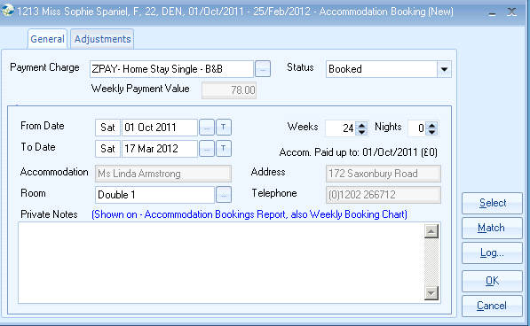

Note: The weekly payment value is the wk1 value from the price list & is displayed for information only.

Select the “Adjustments” tab to see history of changes.

