
Class – Help Document

Problem – Office Macro Security issues with Class
To be done in both Word and Excel per user.
(Every user on a system who has Office 2007/2010/2013)

Macro security is affecting the use of Microsoft Word to access Class and files on the shared area.
We suggest you add the Mapped drive as a safe area and the Class DIR (C:\program Files\Class for Windows SQL\)

Open up Microsoft Word:
Select: File / Options
Highlight “Trust Center”
On the right of this screen select Trust Center Settings…
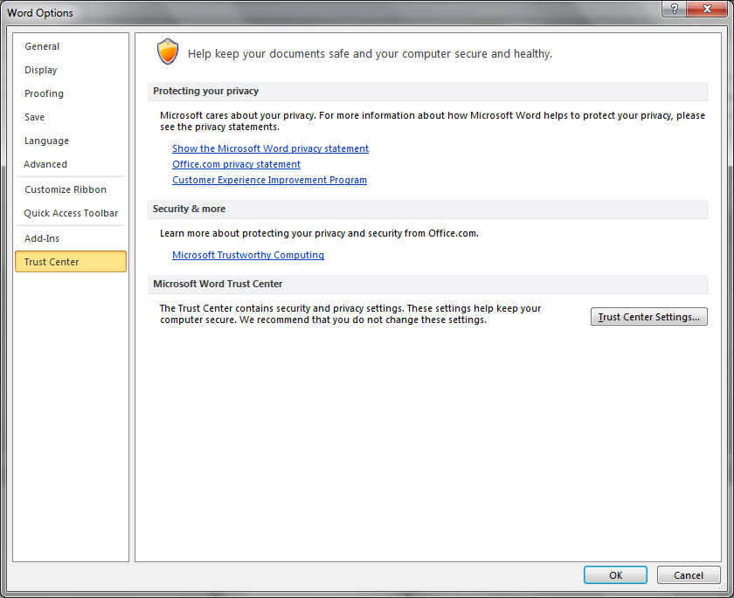
Highlight “Trusted Locations”
Tick ‘Allow Trusted Locations on my network’
Select “Add new location…”
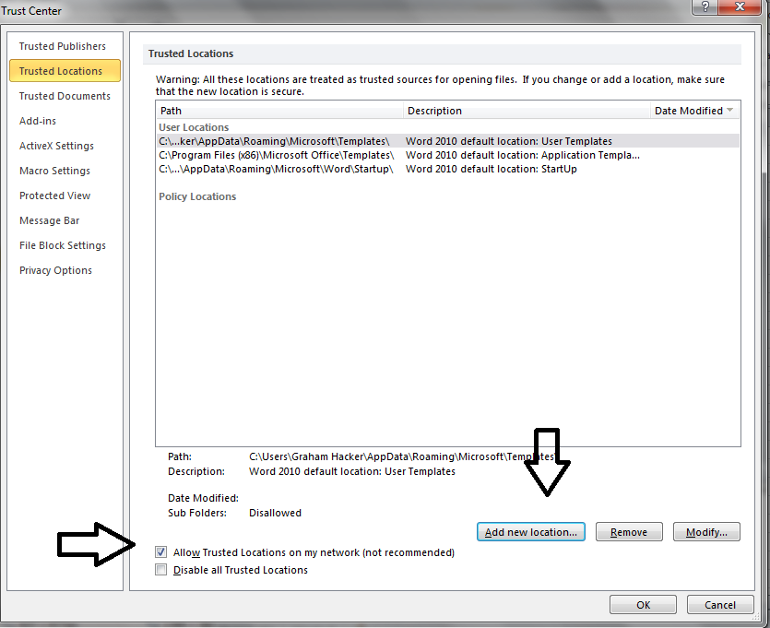
Select the drive letter mapped for Class.
Example: If ‘X’ is your mapped Class drive input the Path: X:\
Select OK
Tick ‘Subfolders of this location are also trusted’
Select OK

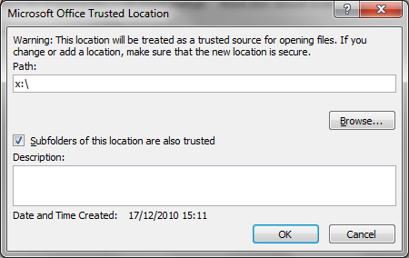

Highlight “Trusted Documents”
Ensure your screen is set similar this:
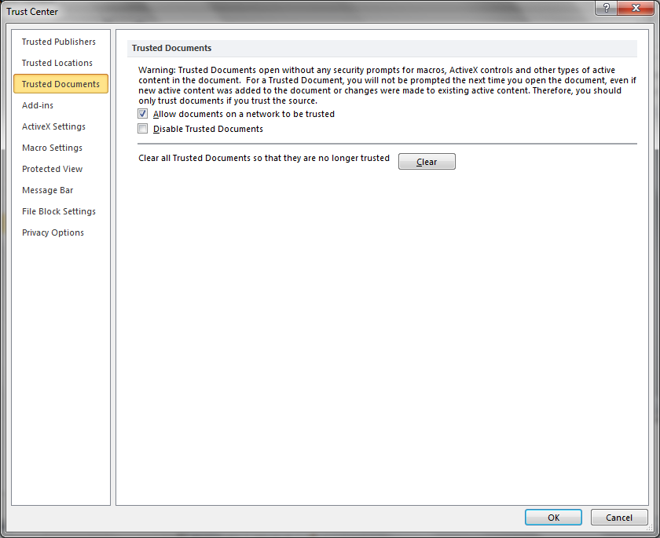
Highlight “Add-ins”
Ensure your screen is set similar this:
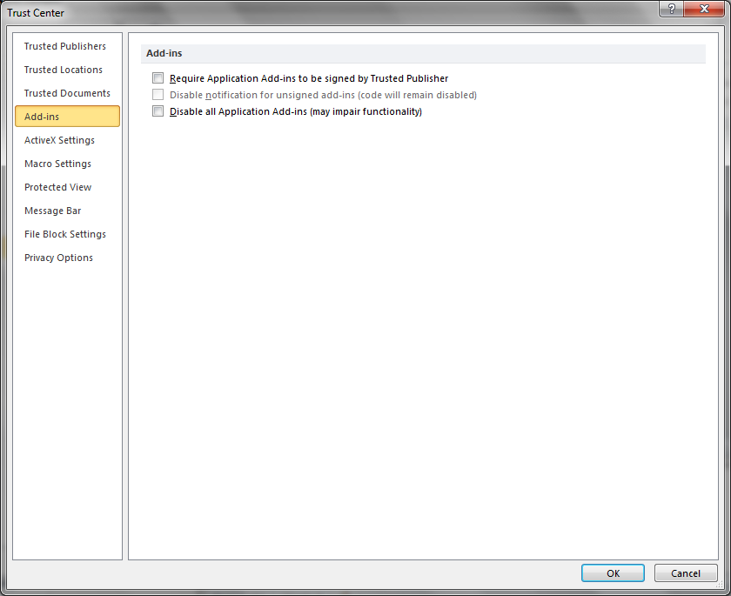
Highlight “ActiveX settings”
Ensure your screen is set similar this:
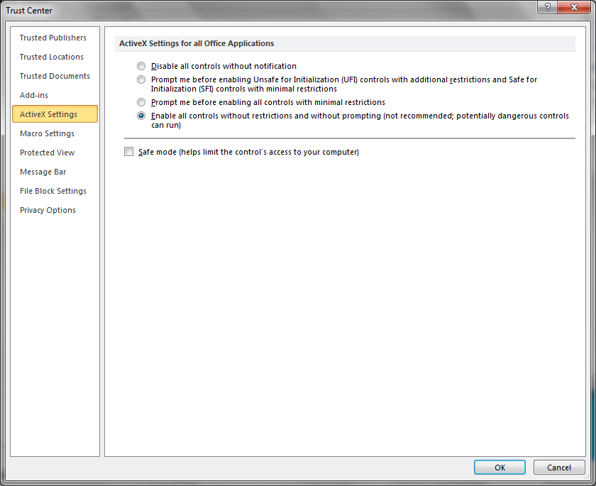

Highlight “Macro Settings”
Ensure your screen is set similar this:
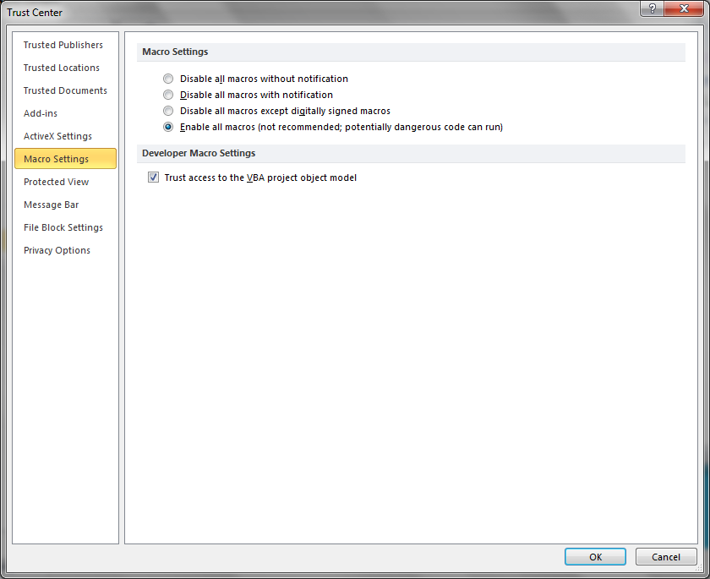
Highlight “Protected View”
Ensure your screen is set similar this:
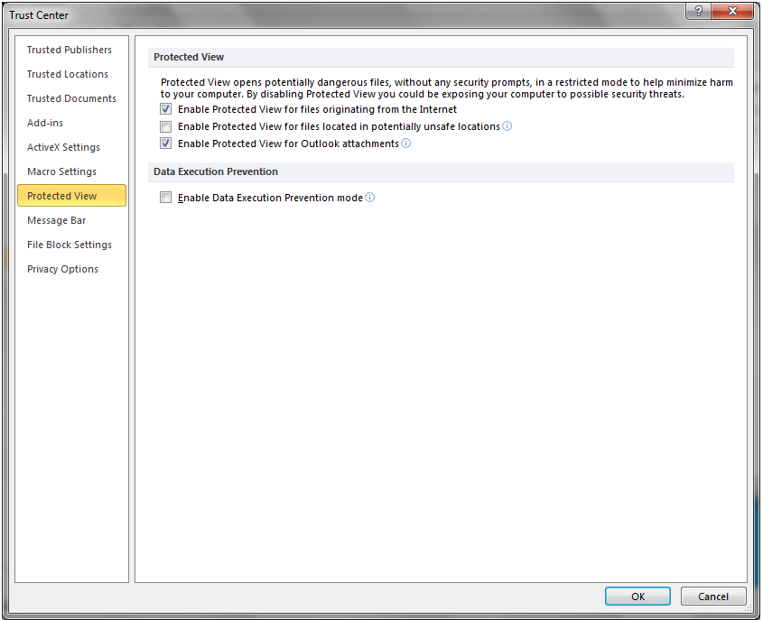
Highlight “Message Bar”
Ensure your screen is set similar this:
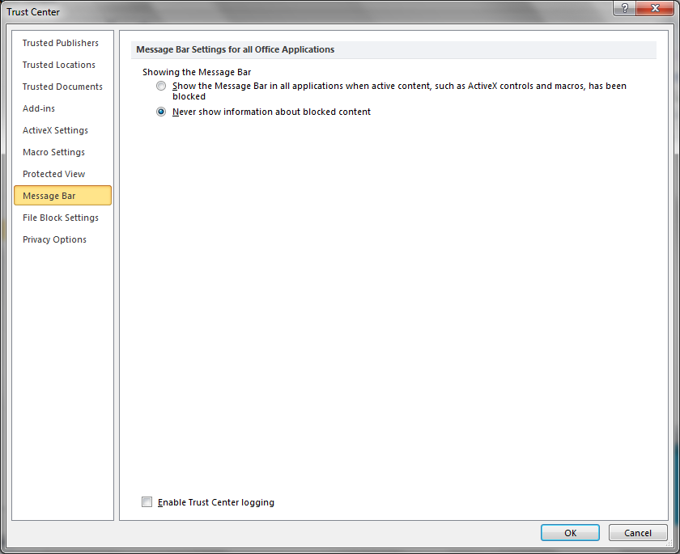
Highlight “File Block Settings”
Ensure your screen is set similar this:
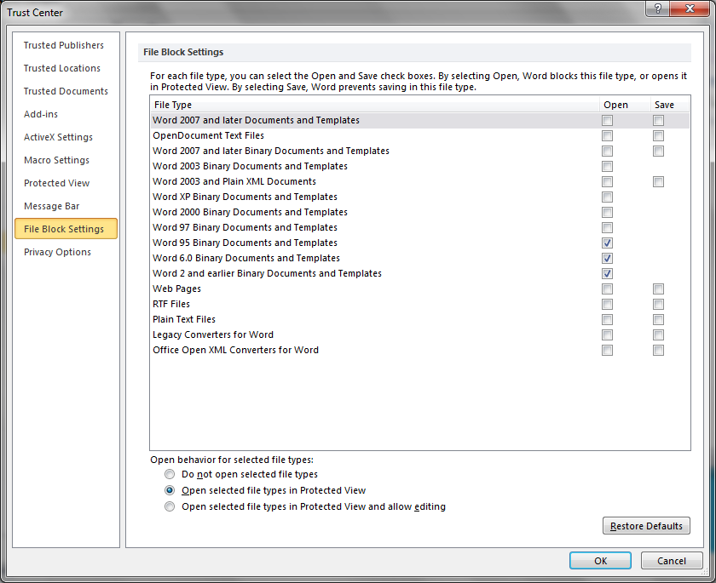
Select OK
Select OK
For Microsoft Excel:
Follow the same instructions for Word but there is one extra screen:
“External Content”
Ensure your screen is set similar this:
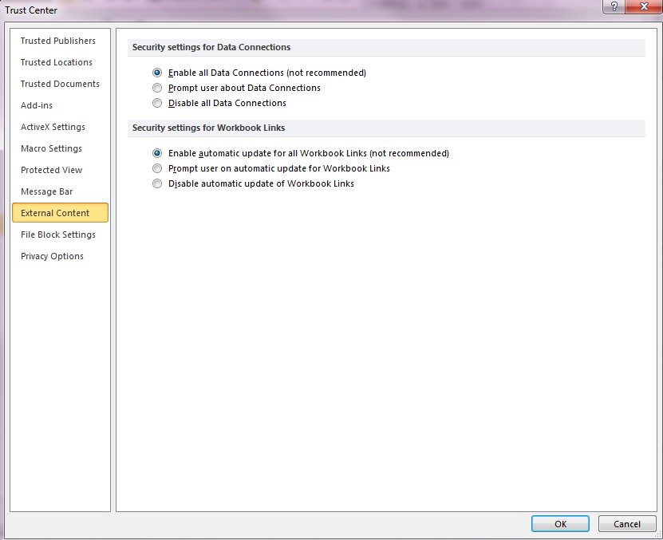
“File Block Settings”
There are not changes to be made to the section for Excel.

FOR OFFICE 2013 USERS ONLY
Please follow these instructions:

Open Microsoft Word:

Click File in the top left hand corner:
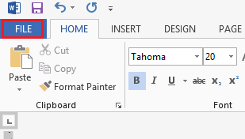
Select Options:
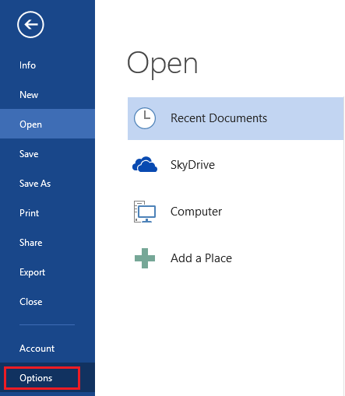

Un-tick the box ‘Open e-mail attachments and other uneditable files in reading view’

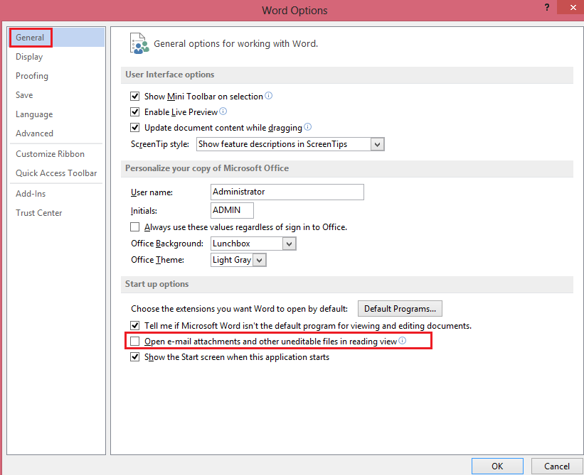
Select OK
Note:
You may need to close Word and Class and log back in to bring the change in to effect.

