Class – Help Document


Import - Agents

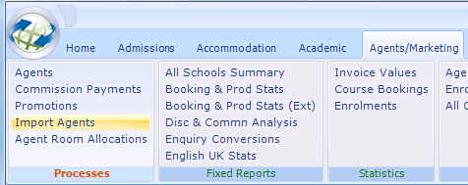

Overview
The import function allows a file of Agents to be imported into Class.
The file must be in ‘csv’ format (an Excel file can be saved in csv format).

The file to be imported must conform to the format given in the “Create CSV Template.”

Import File Format

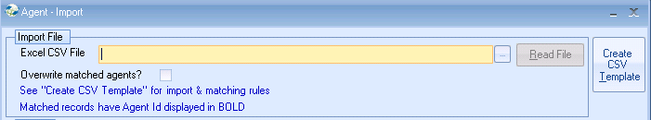

Select the ‘Create CSV Template,’ to see details of the layout and the rules that are applied.

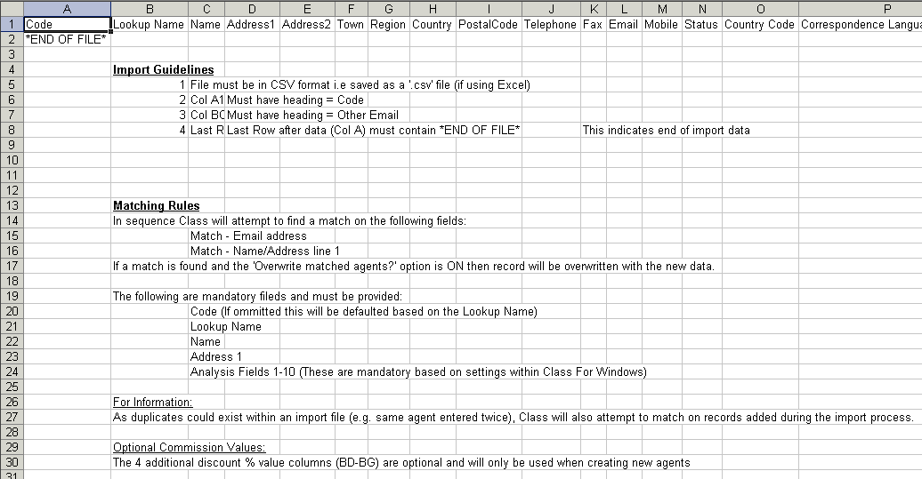

A file not conforming to the above will not be recognised and, therefore, not imported.
There is no danger if a file is “imported” multiple times as matching records will be overwritten with the same information.

Import Process

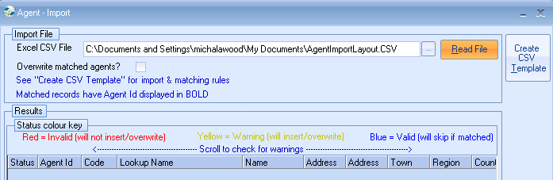

- Enter file name, or use the browse button to search for the import file.
- Select from the other options as required (“Import as” is mandatory).
- Select “Read File,” to initiate the checking process.
- A count will appear in the top right hand corner.

Blue – indicates the record is okay to import.
The Agent Id will be blank
However, if an Agent Id is displays this indicates that the record already
exists in Class and the agent will not be re-imported.

Example:



- On completion the screen will indicate which records will be imported or rejected. You may need to scroll the screen to see invalid fields. Alternatively, the Excel button can be used to print the results for further scrutiny.
- Once satisfied select, “Import.”
- A pre import summary will advise the status.
- An Import Summary will advise the results of the Import.

