Class – Help Document


Booking/Production Statistics Extended

Problem

I need a report that shows the comparatives for up to 5 years, as opposed to this year/last year only.

Up to 3 values each year can be displayed:
- Gross
- Gross Less Discount
- Gross Less Discount & Commission

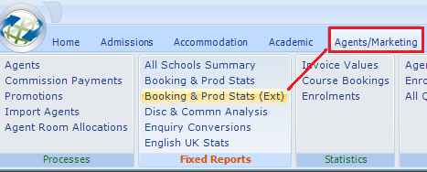

Or

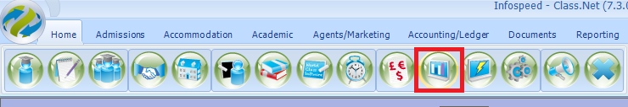

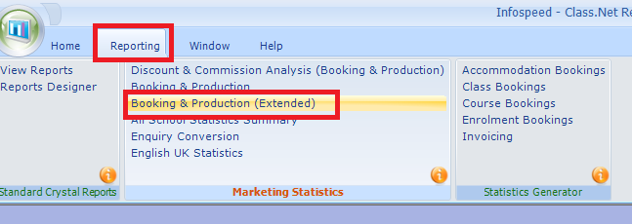

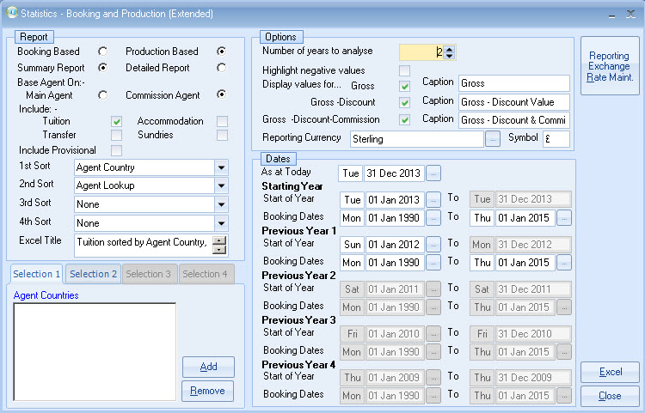

Booking Based - are based on the date the booking item was entered into the system
Production Based - are based on spreading the enrolment element (eg. Tuition) over the duration of the time (Course) booked.

Summary Detailed - Always use Summary as the Detailed report is for auditing the data.

Main or Commission Agent - It is recommended that the “Commission” agent be used for the statistics. This means that direct bookings, which have a commission agent, will be attributed to the “Commission” agent, not the “Direct Agent”.

Tuition/Accommodation/Transfers/Sundry - Select as appropriate

Include Provisional - Only tick if provisional enrolments are to be included.
Sort Fields - Select as appropriate:
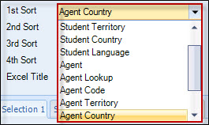

For each Sort field that you have an entry in a Selection tab will be made available. This will allow you to filter on each of the Sort items.

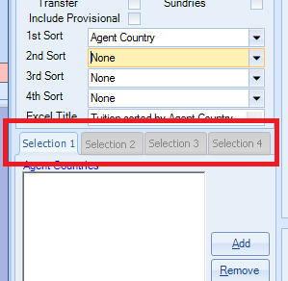

Reporting Exchange Rate Maintenance – The exchange rates are for reporting purposes only and are not used anywhere else within Class. They need to be manually input in the following screen:

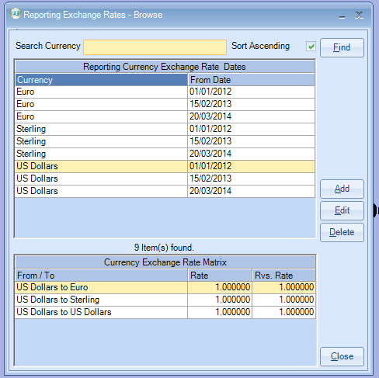

An example for its use: Over the past 3 years various exchange rates could have been used when producing invoicing but for this report you may wish to run it using current rates.
Number of Years to Analyse - Enter number required (1-5)
Display Values For - To make the report smaller, deselect values not required.

Reporting Currency - Select as required
As the comparatives can be shown in any single currency and over a significant period of time, exchange rates can also be entered across the range of dates.
This could be a single exchange rate for the whole period, a rate per annum or in theory a rate for every day.
The standard Booking & Production statistics use the single exchange rate in the system settings (invoice system settings).

Dates - Restrict as appropriate. Production stats allow the booking dates to be entered. For example, you can measure the amount of “production” this year attributable to bookings entered (received) this year.
When compared to last year, it can be seen whether the current year is more, or less, dependent on bookings received this year, than it was in the previous year.

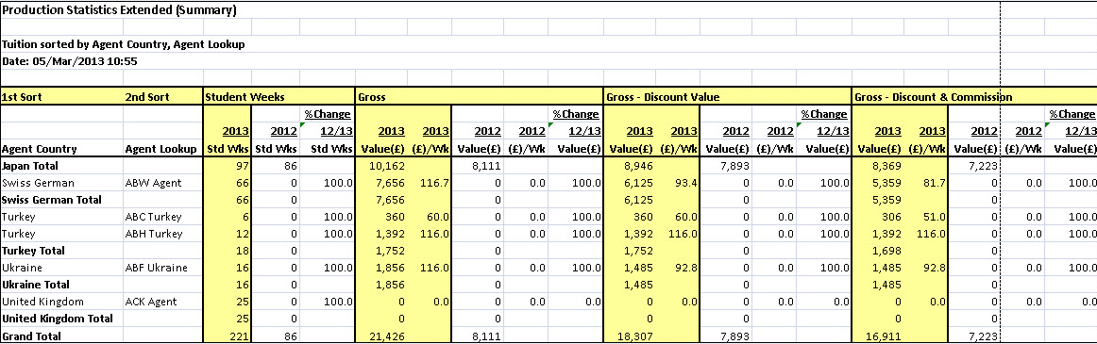

Explanation of each of the column headings in the above report
1st Sort and 2nd Sort – taken from the Selection screen

Student Weeks
The value is taken from within the students enrolment.
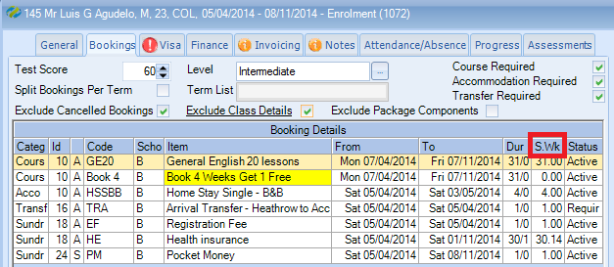

% change
The difference as a percentage in the values for the year(s) being reported on.

Gross Value
This is taken from the “Basic” column

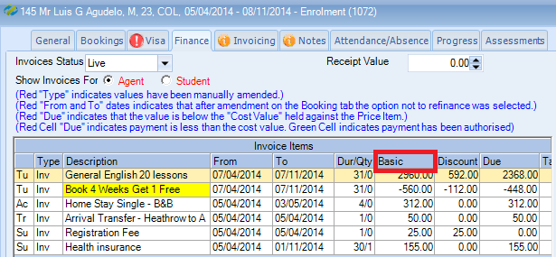

(£)/Wk
The average value per week i.e. Value divided by Std Wks

Example for use of the date filters

All students who have studied in the school from 1st January 2014 – 30th September 2014.

The actual booking must have been entered into Class during January of each year.

