Class – Help Document


Changing Weekly Course Rates

Problem

I would like a student’s course to remain priced at a 20-week rate, even if the student splits their 20 week stay between 2 courses (priced either the same or differently) of, for example, 2 x 10 weeks.

Solution
Under an existing enrolment which you would like to change, or when adding a new one, please ensure to choose the appropriate amount of weeks.

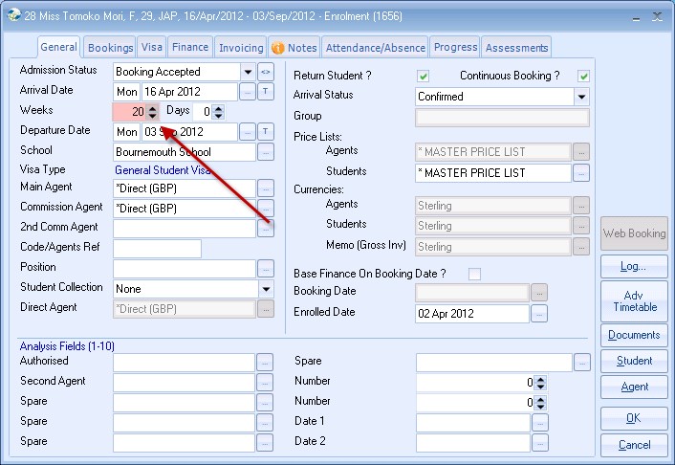

When adding the 1st course (General English 15 - which lasts 10 weeks), change the charge rate to 20 weeks…

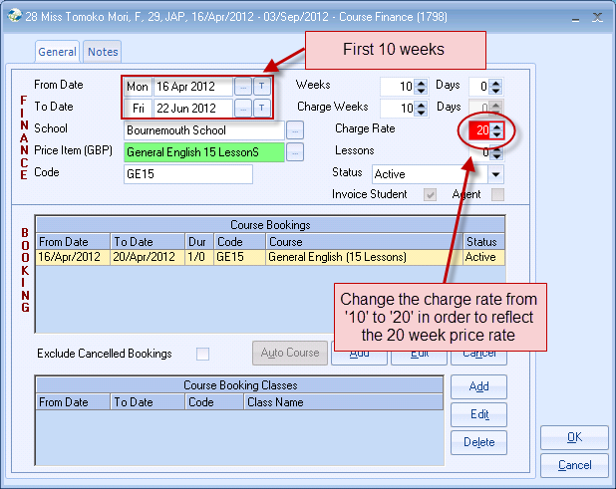
…& this will then pick up the price of 20 weeks from the General English 15 Price List:

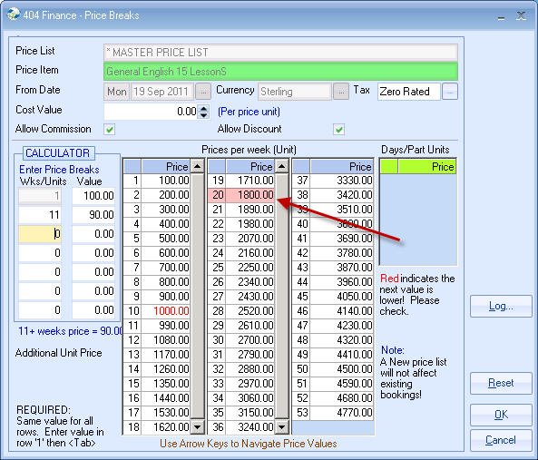
When adding the 2nd course (General English 20 - which ALSO lasts 10 weeks), again, change the charge rate to 20 weeks…

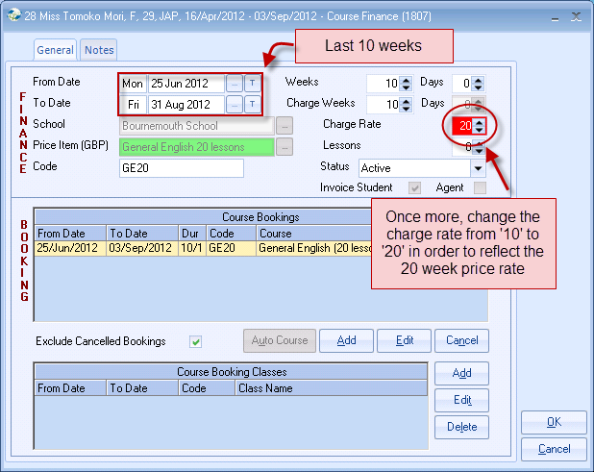

…& this will then pick up the price of 20 weeks from the General English 20 Price List:

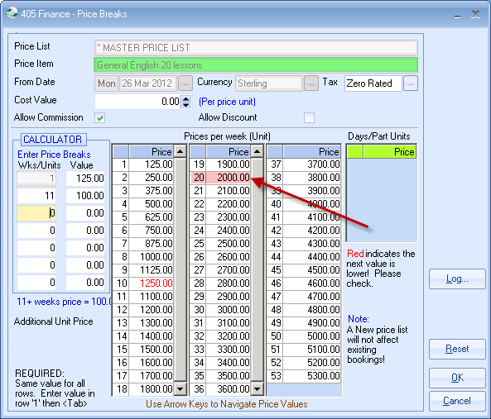

Now, when you look at the finance, it will correctly reflect the amendments made:
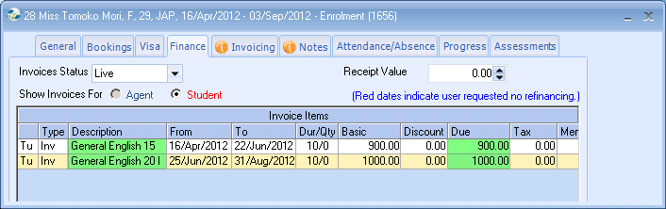

For General English 15 lessons:
Week 20 price rate = £1800
/ 20 weeks “charge rate”
X 10 weeks on this course
= £900!

For General English 20 lessons:
Week 20 price rate = £2000
/ 20 weeks “charge rate”
X 10 weeks on this course
= £1000!

