Class – Help Document


Enrolment Terms

How to set-up and create “Enrolment Terms”

Go to: Maintenance/Settings > General Settings > Company > Company
Enrolment / Enrolments – Enable School Term Option:

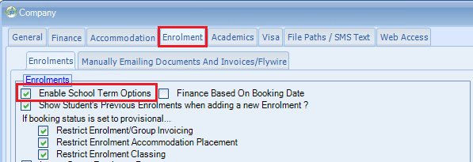

Set up the terms and dates within Settings > Company – School Term Periods:

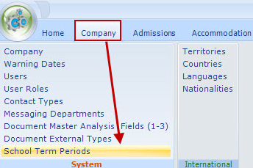

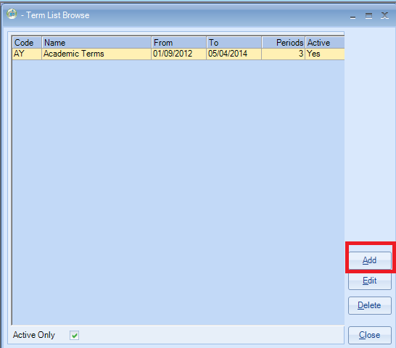

Name: Input the name of this set of terms
From/To – Input the range of the complete set of terms

Note: You do not need to add a new Term List for each academic year but you could keep extending the “To” date and adding to the “Terms” section.

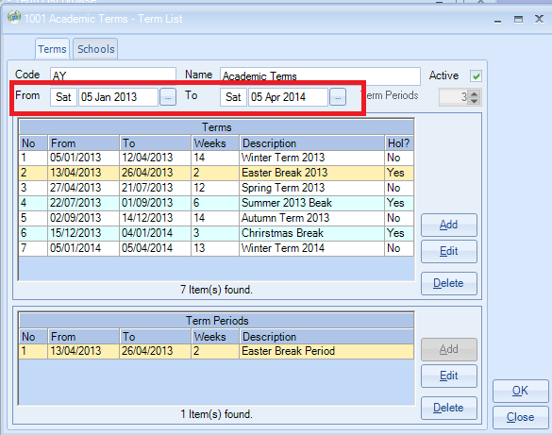

“Term Periods” relate to the number of sections that make up a Term

To create the entries within the “Terms” section click on “Add”.
In this example the “Term” is split into three sections.

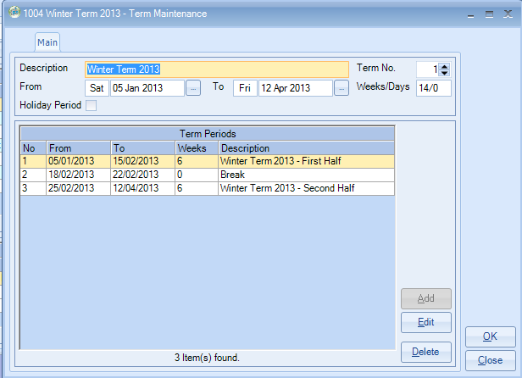

The “Holiday Period” box was ticked when creating the Break entry.
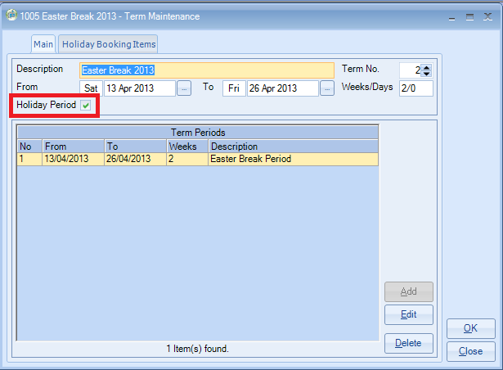

Select the “Holiday Booking Items” tab
By selecting a Holiday Item this will mean that when using the Terms within an enrolment the student will automatically be put into a Holiday Break Course.

Note: You can create a default Holiday Break Class within the Holiday Break Course.

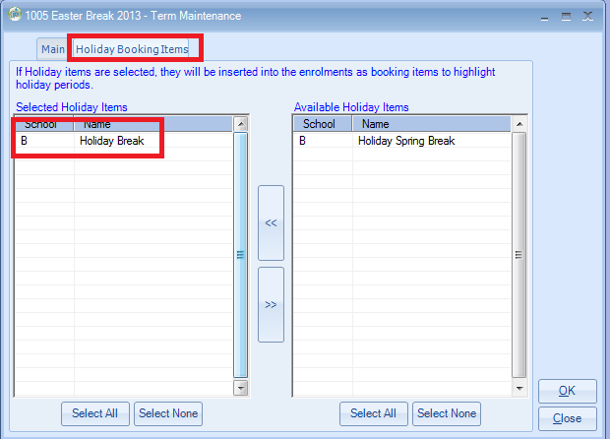

Highlight the “Schools” tab and select the school(s) that this set of Terms relate to.

Using Terms within an Enrolment.

In this example the student will be studying for the complete academic year.

Arrival Date: Click on the “T”
A screen will be displayed similar to the following:

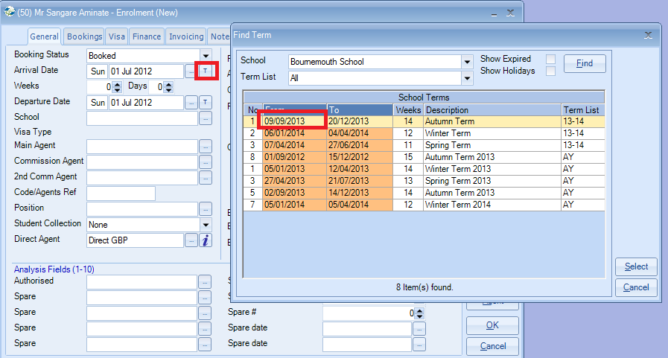

Term List – Select on the list that applies to this booking.
Select the Start Date of the first Term.

Note: You can have a number of Term Lists as even in one school you may have different Term Start and End dates depending on the course that the student is studying.

Departure Date: Click on the “T” and select the End Date of the last Term

Complete the rest of the General tab in the normal way.

Bookings Tab
From and To Dates – Should be correct but if you need to change them then click on the “T”

Select the relevant Price Item.
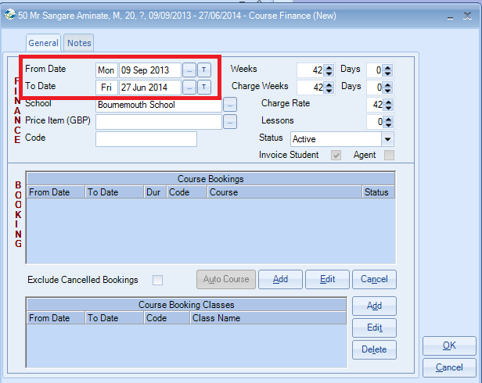

You will have a similar screen to the following:
Note: If the “Split Bookings Per Term” is not ticked then one line for the complete stay would be inserted.

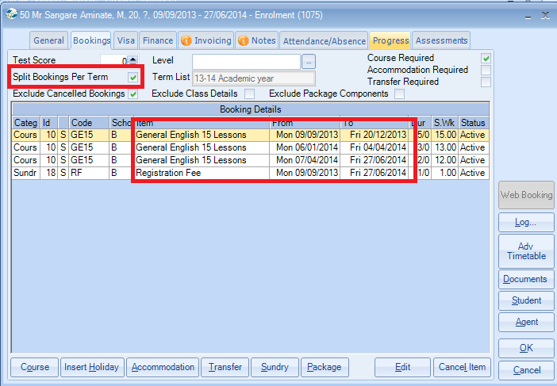

Finance Tab

Each Term will be listed separately.
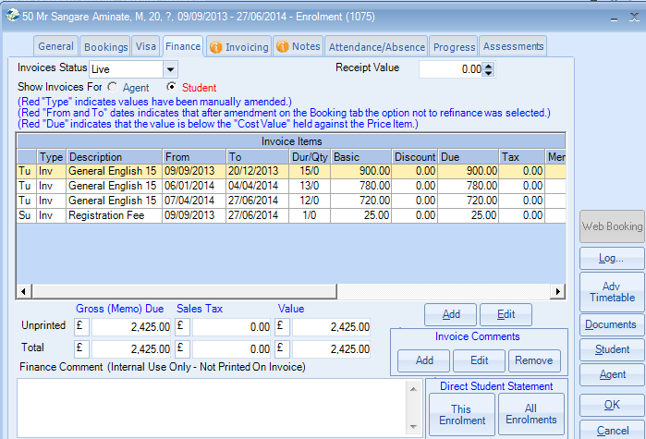

If you only wish to invoice for a particular term instead of the complete enrolment then ensure that the “Invoice Per Term” box is ticked.
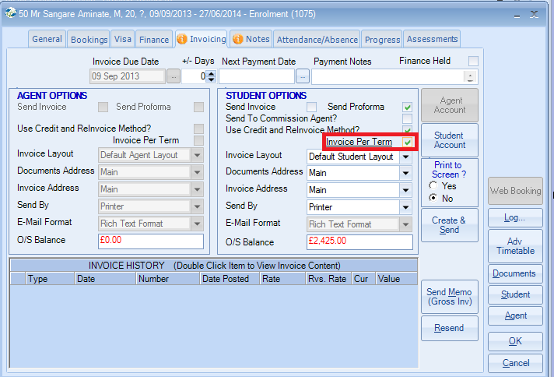

A screen similar to the following will be displayed and then you can select which “Term” you wish to invoice for.

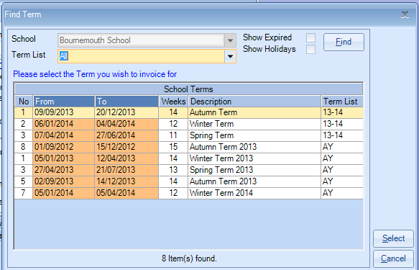

In this example of an invoice, only one Term is being invoiced for.

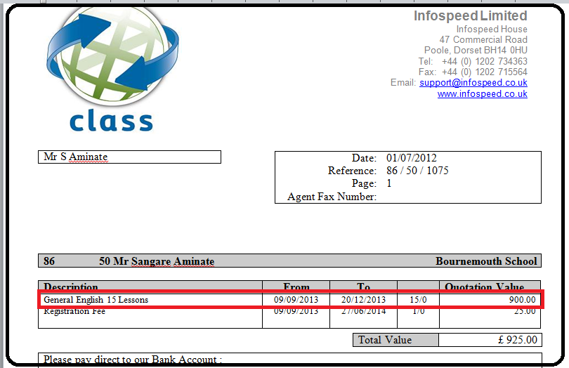

Terms and Packages

If some courses do not run for all the “Terms” then you can use Packages within the set-up to accommodate this.

Create a Package similar to the following:
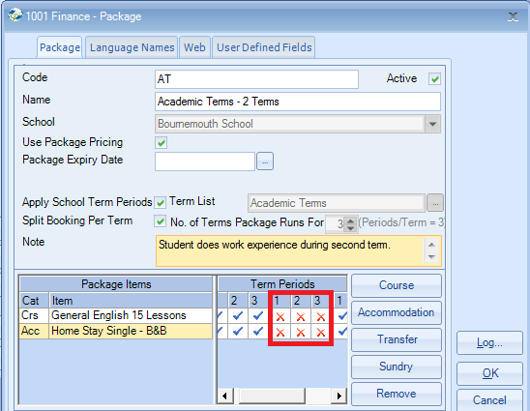
The red crosses indicate when the course will not be running.

Insert a “Package” as normal.
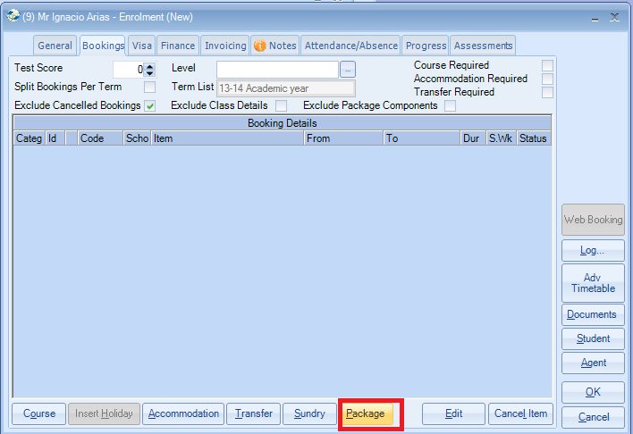

A screen similar to the following will be displayed.

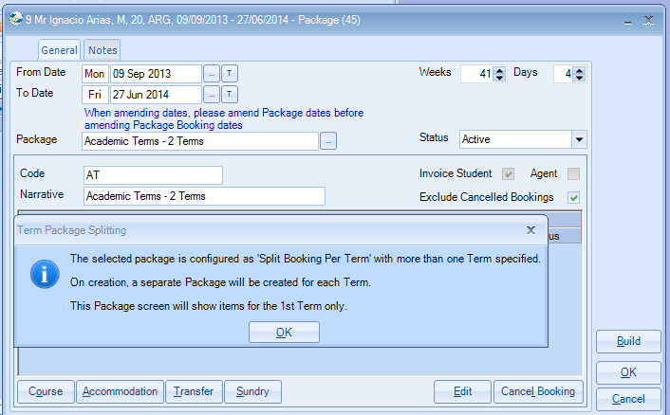

If the “Split Booking Per Term” was ticked when you created the “Package” then the following will be inserted when used within an Enrolment.

One “Package” for each of the “Terms” created.
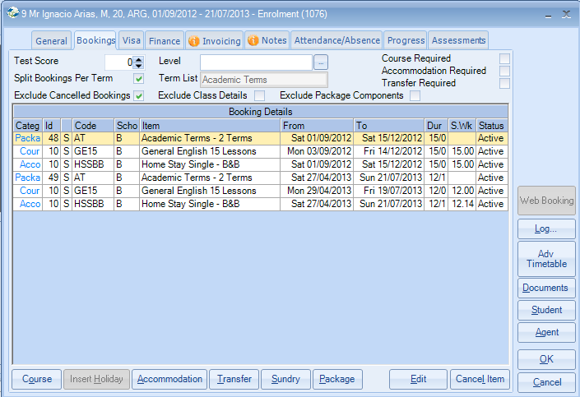

If the “Split Booking Per Term” was NOT ticked then providing the Terms are consecutive then they will be included within one Package.

