Class – Help Document



Quick Report Permissions

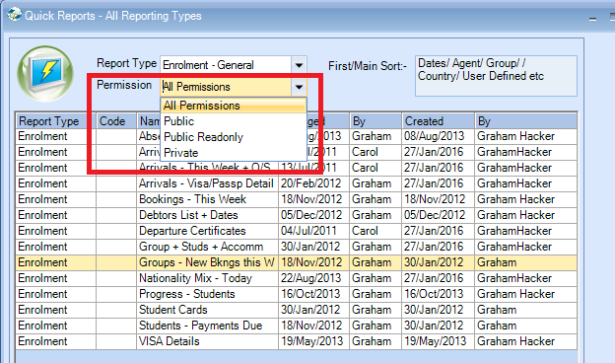

Public Any one can change and use the report
Public Read Only Only the owner of the report can change it.
Private Only the owner can change and run the report.

Users with Administrator rights can amend all reports.

