Class – Help Document


Uni-Pay, Class & Class On-Line

This document is assuming that you already have a Uni-Pay account created.

Unipay can only be used for Direct bookings NOT for bookings via an agent.

Before you start using Uni-Pay, you need to create your master template for the email that will be sent to students.

The content of the email is your choice, but an example would be:

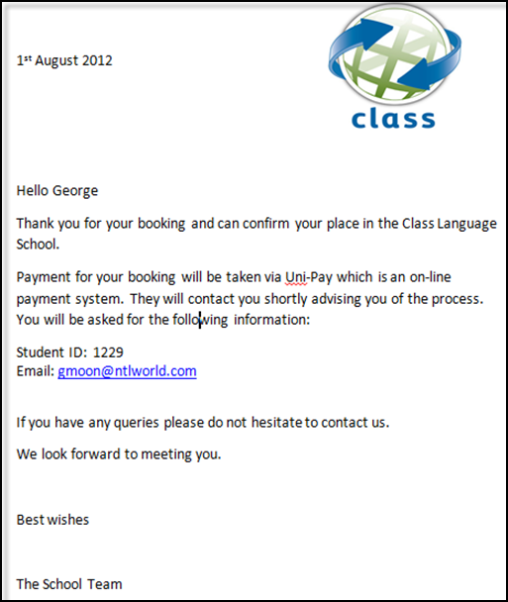
To create and set the default email template

Create the template:

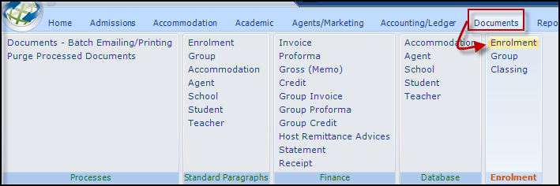

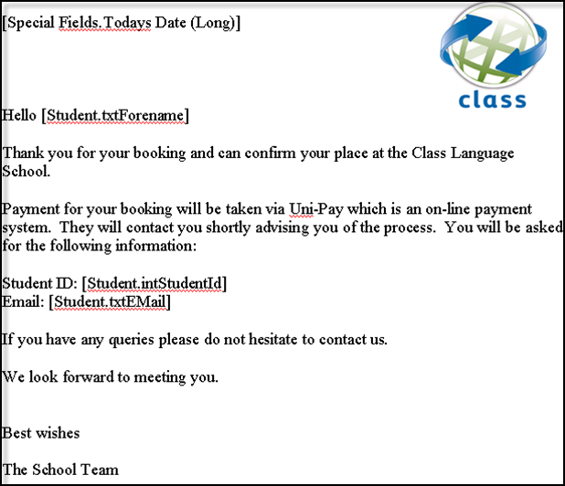

Set the default email document:

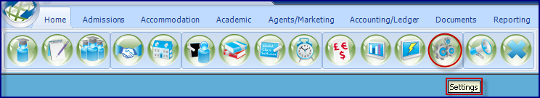

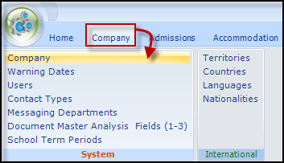

Select the document template that you have just created:

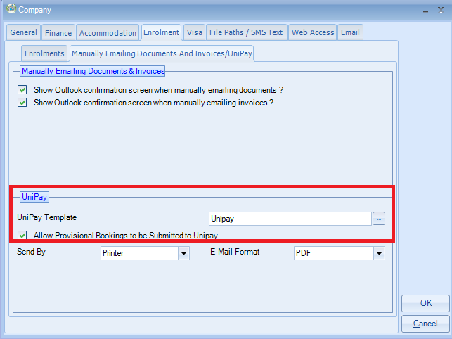
You also have the option to Allow Provisional Bookings to be submitted to UniPay.

Create the Unipay Accounts

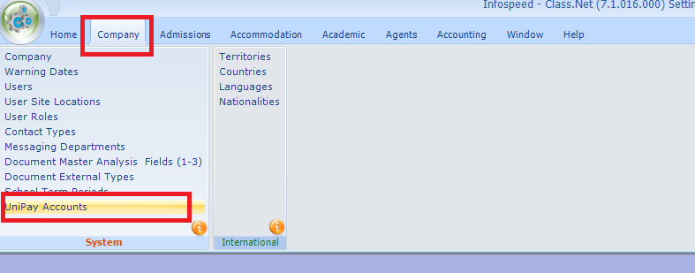

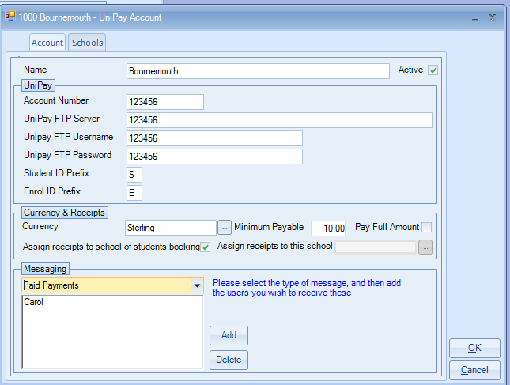

Name: Select the correct school. An account should be created for each school.

The following three fields are not currently used so suggest you input as per the example given. These fields will be removed within the near future.

Unipay FTP Server: Not used
Unipay FTP Username: Not used
Unipay FTP Password: Not used

Student ID and Enrolment ID Prefix: Suggest you use S for student and E for enrolment.
These are added to the ID numbers when sent to Unipay. They are not used within Class.

Currency: Select the currency required.
Minimum payable: You may wish to set a value e.g. £10
Pay Full Amount: If ticked will restrict part payments

Messaging: This is by category:

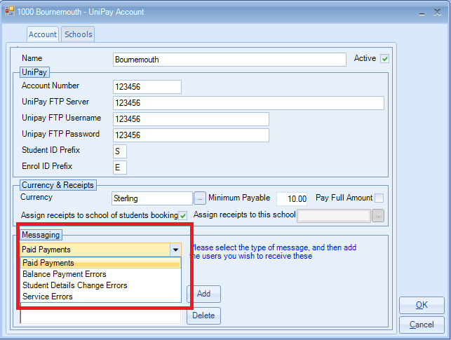

Add the users that you wish to receive a message when any of these occur.
These will be received in the yellow envelope box in the top right-hand of the Class screen.

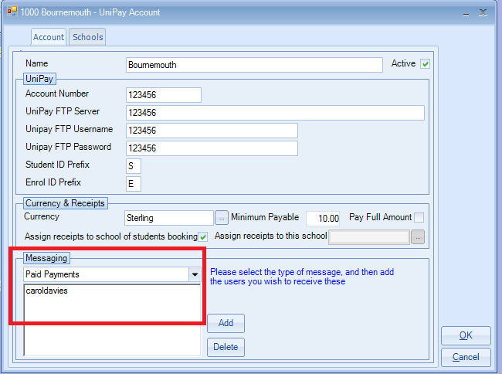

Students Record

Unipay uses the students email address and Date of Birth so these fields must be added within a students recorded.

The email address used is from the student’s Statement Address tab.

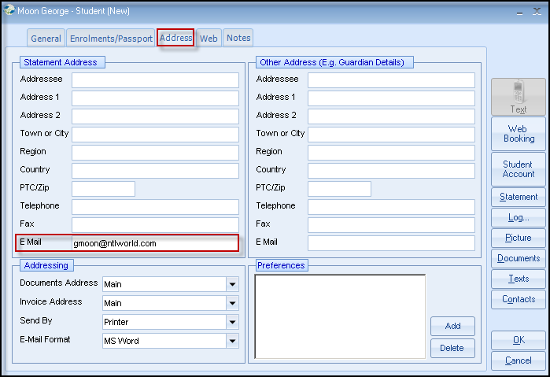

Setting a student’s payment to be collected via Uni-Pay

Add an enrolment in the normal way.
When you exit a direct student enrolment, you will receive a message asking if you wish to collect the payment from Uni-Pay.

If you click ‘Yes’, then the following box will be automatically ticked:

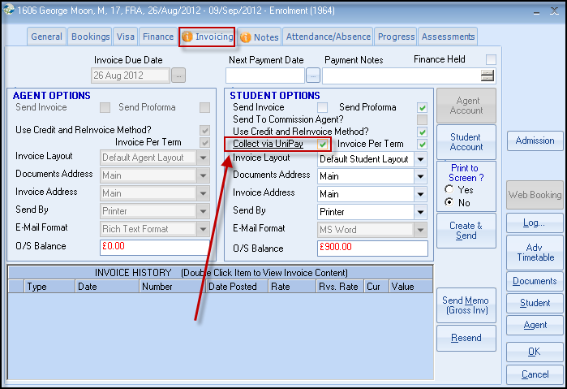

You will only be prompted once for each account if you wish to collect payment via Uni-Pay, and if you want to send the confirmation email.

You can do either manually at a later stage.

This is an example of a confirmation email:

Information: There is a program that sits outside of Class that will scan Class periodically, and then notify Uni-Pay of any new bookings and any amendments that affect the overall finance.
Uni-Pay will send an email similar to the following to each student they are notified of:

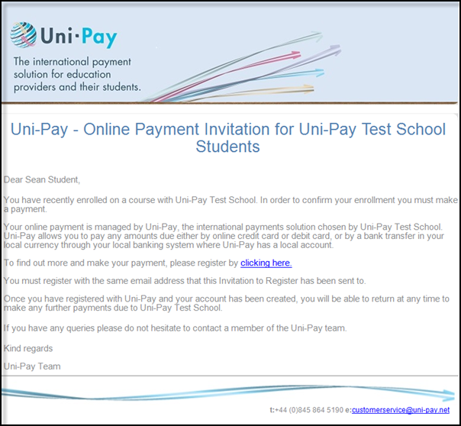

Using Uni-Pay in conjunction with Class On-Line

A list of all the bookings made via Class On-Line will be listed:

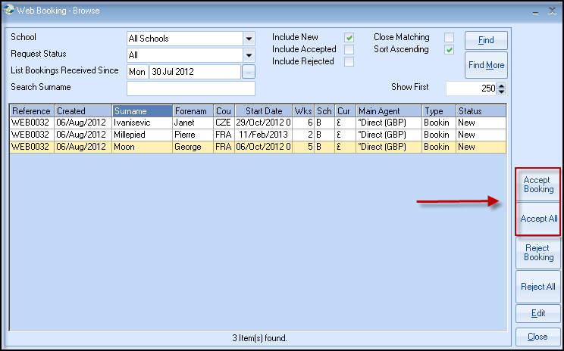

By selecting “Accept Booking” or “Accept All”, you will be able to choose whether the individual booking or all the bookings will have the payment collected via Uni-Pay.

Receiving Payments from Uni-Pay

If the Class Ledger is in use, then all payments received via Uni-Pay will be automatically added and allocated to the correct student.

The Receipt will be added with a Type of “Uni-Pay Bank Transfer” or “Uni-Pay Credit Card”.

