Page 1 of 3

Class.Net – Help Document


Booking Fees/Registration Fees can be set up via the School
settings to be picked up automatically within each students enrolment.
To set this up go to: Maintenance/Settings > Schools…
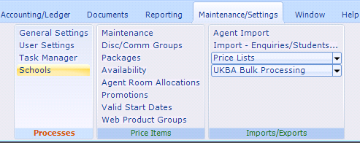
Open up the school and go to the “Rooms/Booking Fees” tab
Select ADD and select the required booking fee(s).
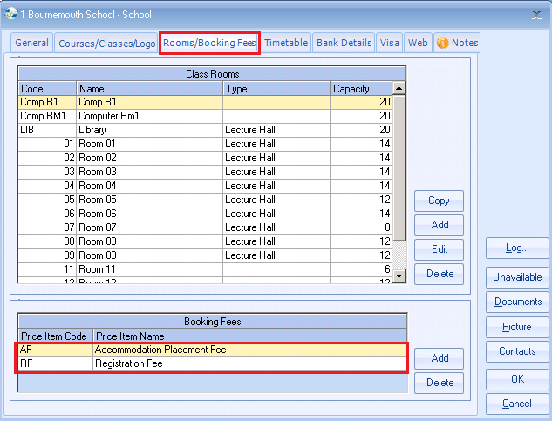
You must log out of Class and back in make this change available for use.

Page 2 of 3
When a new enrolment is added and the course is assigned the Booking Fee(s) set via the school will automatically be added.
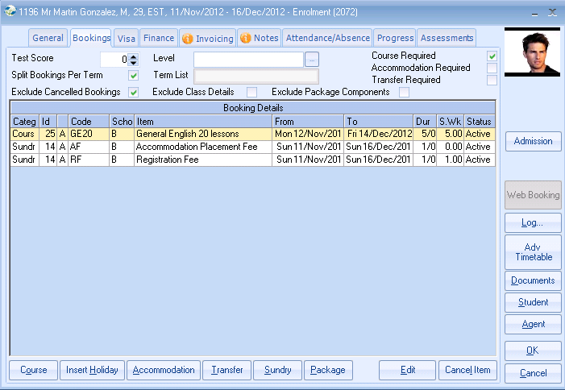
Any agreements made with agents to exclude the booking fees can be dealt with within the agent records.
- Finance Details / General screen:
Charge Bookings Fees? – unticking this box will stop the fees from automatically appearing with the student enrolment when assigned to this agent.
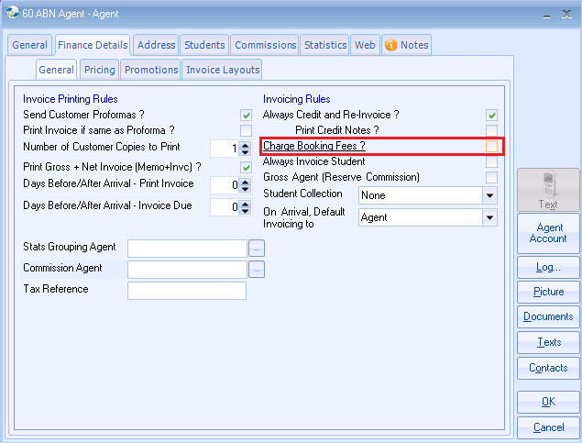

Page 3 of 3

Alternatively, if you wish to show the booking fee on the agents invoice but with a 100% discount, ensure “Charge Booking Fees?” is ticked and set the discount percentage in the Pricing screen:
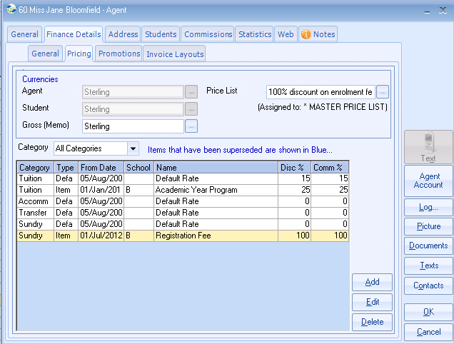
To set this up select ADD and enter the details as follows:
