Class – Help Document


Agent Room Allocations

General

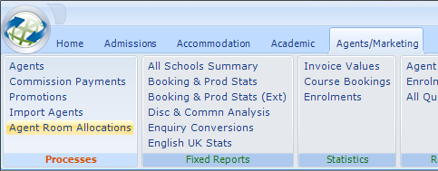

The Agent Room Allocations feature in Class works in conjunction with the Availability functionality. For anyone who is unfamiliar with the Availability features, please review the ‘SQL172 Availability.doc’ for more information on how this works. This will then give you a better understanding of how your product availability is setup and can then be allocated amongst your agents. Availability must be setup first before you can proceed with the Agent Room Allocations feature.

The Agent Room Allocations feature allows you allocate (reserve) accommodation products to your agents, monitor their progress and adjust allocations accordingly. For example, you may have setup an availability list for a specific residence that defines how many beds are available on any given day throughout the year. It is these numbers that are used as a basis for allocations to agents.

There are 2 ways to access “Agent Room Allocations” from within Class:
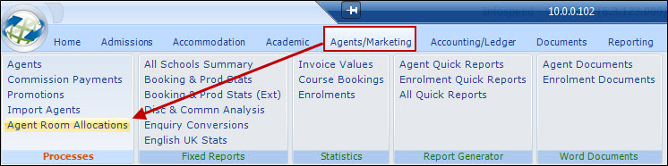
OR
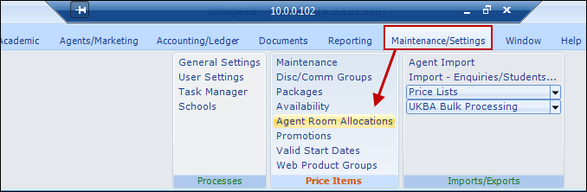
You will initially be presented with the following screen:
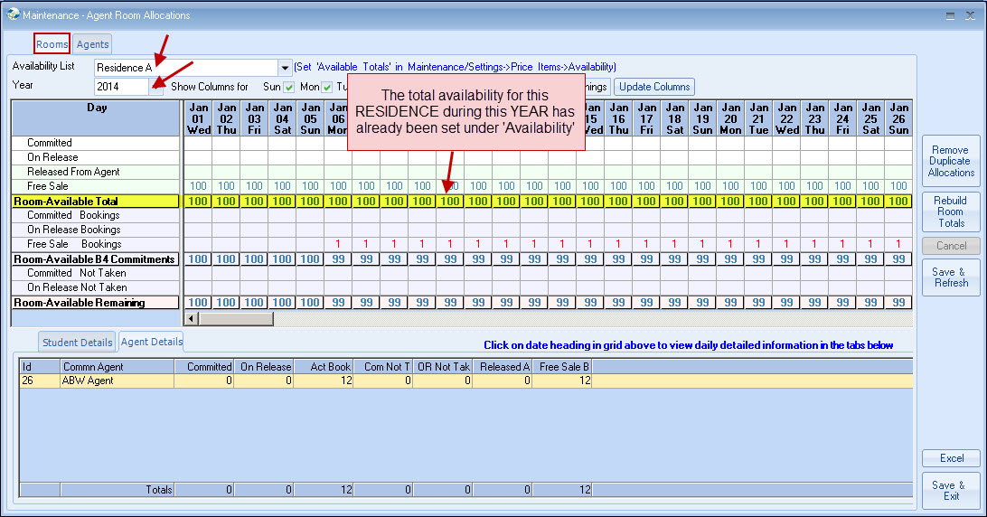
At the top, you can see the ‘Total Availability’ (i.e. number of rooms) is set to 100 rooms for the entire year for this residence.

You enter this figure as follows:
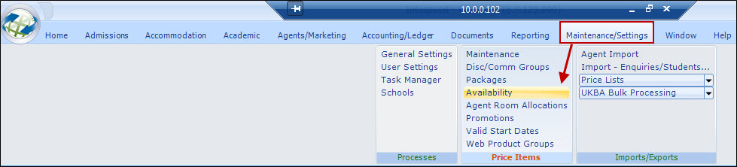
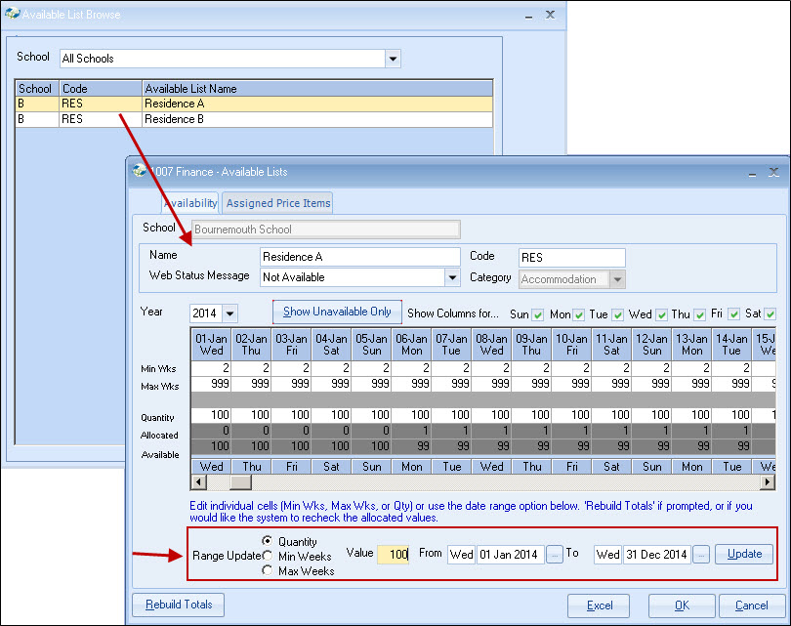
Under ‘Quantity’, you will indicate HOW many rooms/beds are available on any given day for your chosen year. (You might add more rooms during the spring/summer & then less rooms in the quieter winter period – this is all possible here)
Going back into “Agent Room Allocations”, the next step is to now decide HOW you want your ROOMS to be allocated to individual agents. There are 3 types of allocations available:
- Committed : this means the agent has to pay for the rooms even if they don’t use them
- On-Release : this means that if the rooms are NOT pre-booked within a certain time period, they are given back to the school without penalty
- Free Sale : this means that a bed is neither committed, nor on-release, but for sale to anyone. Free Sale cannot be allocated/reserved for agents in bulk but even when agents have been assigned ‘Committed’ or ‘On-Release’, you can still grant them Free Sale allocations when adding bookings.
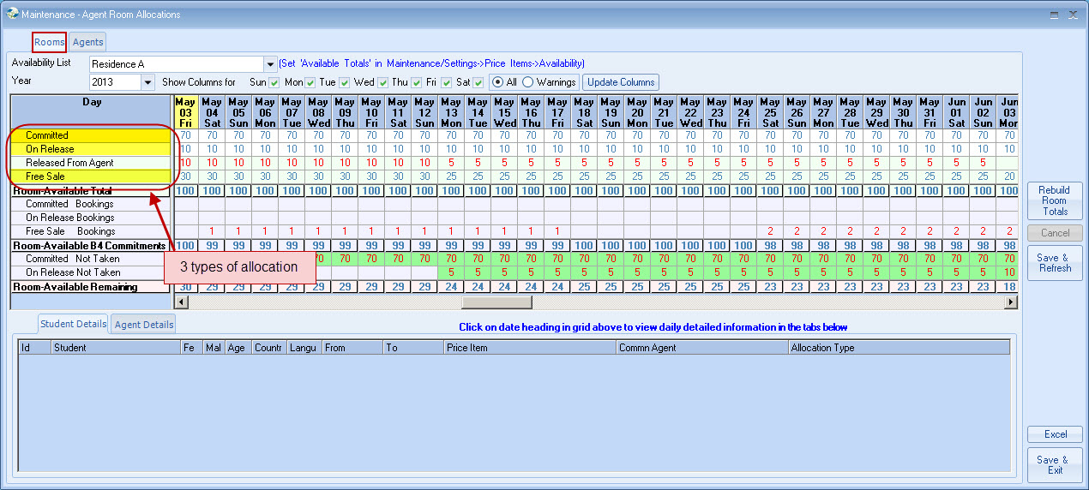
In the above example, you can see that 70 rooms are committed, 10 on-release.
Any rooms remaining (30 in this case) will automatically be classed as free-sale.
The next step is to allocate committed & on-release rooms to the individual AGENTS:
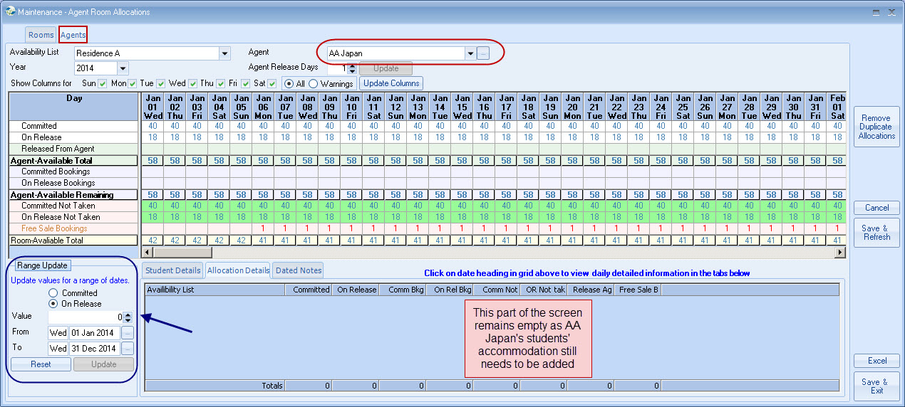
The blue box above shows you where to add committed and on-release items respectively – in this case 40 committed and 18 on-release.
Now that the total number of rooms for the schools have been allocated, AND the number of rooms for 1 particular agent, we can add a student into AA Japan’s assigned accommodation to see how this works.

We go into a student we know has AA Japan as an agent, and add an accommodation item:
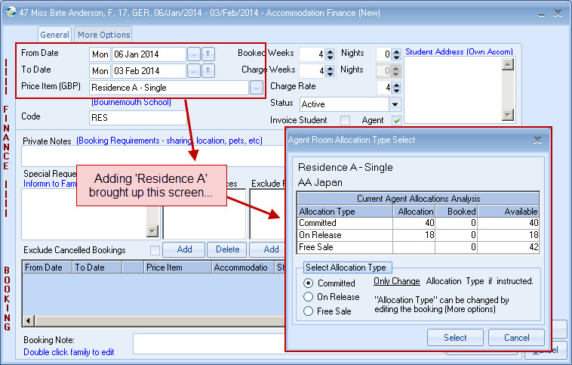
Once you have entered your dates and the correct price item (Residence A) , the box above pops up - due to the fact that you have just finished allocating rooms for AA Japan under "Agent Room Allocations" (see previous screen). This box now allows you to choose whether you want this student's accommodation to be 'committed' or 'on-release'.
In this case, Birte will be 'committed'.
On the below screen, you can see that 1 room is committed:
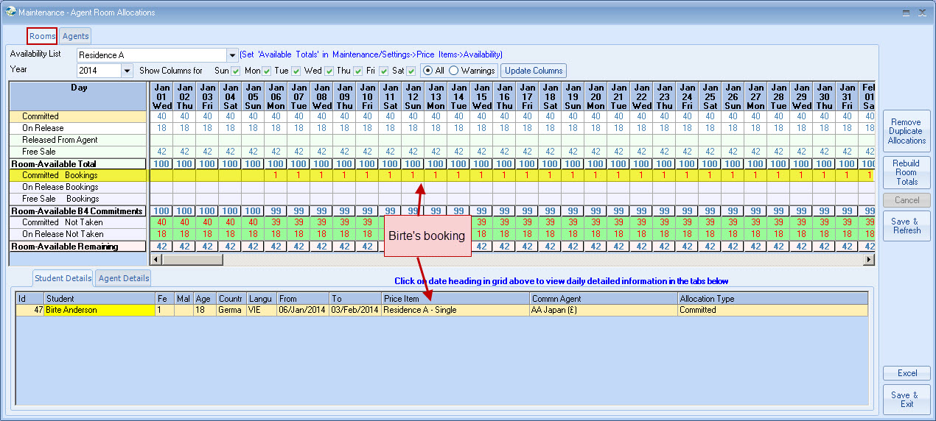
The same changes will be applied on the agent side (if you click on the agent tab at the top of the screen).
A few additional things to note:
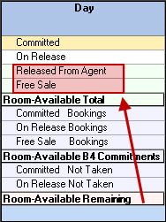
On the left hand side of both room & agent screens, you will be able to see a better breakdown of which allocations a school/agent has, & what they have used or not.
Towards the top, highlighted in red you can see which rooms have been released back to the school by the agent, giving the school the chance to sell the rooms on to other agents or direct students.
2.
