
Class – Help Document

Documents – Batch Processing

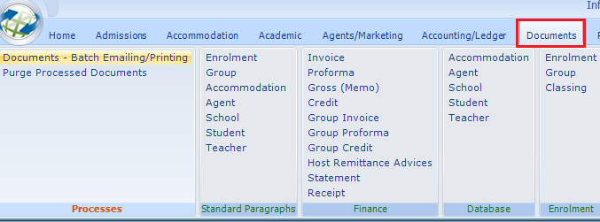

Enables unsent documents to be merged and sent all together. A mix of print and email can be handled by the system. A wide range of selection options is available.

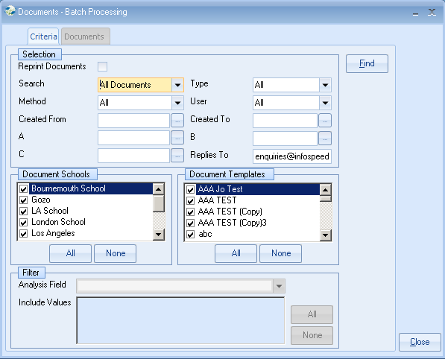

Find
Click this button to find all matching merged documents.

Close
Click this button to exit the program.

Selection Criteria
Type
Select from one of the following categories.

All
Accommodation
Agents
Enrolments (All – including Groups)
Enrolments (Non Group)
Enrolments (Group Only)
Groups
Groups (Including Enrolment)
Schools
Students

Method
Select document output from:

All
Printer
E-Mail

User
Select “All” or name of user who created the document.

Created From/To
Enter the range of document creation dates to select on.
One or both of these may be left blank (no check performed).

Force Replies To
This only applies to e-mails. Use this to attach a different e-mail address to replies.

Document Schools
Select “All” to include documents for “All Schools” or “Selection” to choose from one or more schools.

Document Templates
Select “All” to include all documents or “Selection” to choose from one or more specific documents.

Enrolment Analysis Filter
This filter is only available when “Enrolment” types are selected.
Select Analysis field to be used then tick items to be included.

Matching Documents

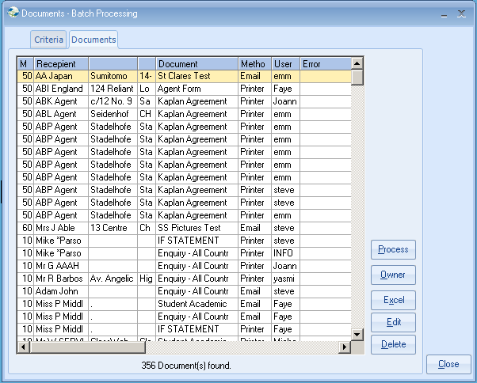

The number of matching documents is shown at the base of the grid.
Documents shown in red have an error on a critical field. For details of this error view the last column.

Process
Before proceeding confirm that there are no copies of Word open.

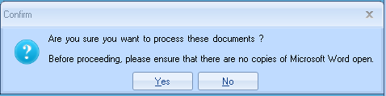

After confirming all documents listed (without errors in critical fields) are merged and sent to their output destination (printer or e-mail).

Owner
This shows the main details behind this document. E.g. for an agent document it will show the agent details, for an enrolment document it will show the enrolment details.

Excel
This sends this list of matching documents to Excel.

Delete
A confirmation box is displayed before the selected document is removed.

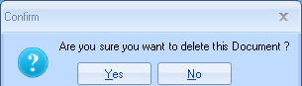

Edit
This allows certain fields relating to this document to be changed.
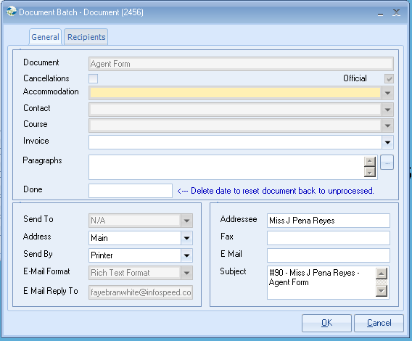

Those fields that do not apply to that type of document are disabled. E.g. host & course bookings only apply to enrolments.

The documents that are processed are updated and displayed within the Documents tab of the students booking.

